Structural Plan:

Table of Contents

LINUX 1

AWS EC2 18

Bash Scripting 18

GIT 18

MAVEN 18

CONTINOUS INTEGRATION 18

JENKINS, SONAR, JFROG ARTIFACTORY. CONTINOUS DEPLOYMENT: ANSIBLE DOCKER 18

KUBERNETES: 18

# LINUX

**LINUX**

**Summary of the tools:**

**DevOps:**

Developer gives a piece of code(website). **Devops** engineer has to copy this code on to the server.

**Devoper side:**

I will give code **everyday** or  **couple of times**  in a day.

**Compile**  and deploy it on  **test** and  **prod** servers.

**Prod**  servers are used by **Client.** So it should be  **up and running** all the time.

Let's go through all the important topics in DevOps and AWS Cloud again. This way, you'll have a better understanding of the entire course and get a clear picture of how everything works.

LINUX:

AWS EC2:

Bash Scripting:

GIT:

MAVEN:

CONTINOUS INTEGRATION:--JENKINS, SONAR, JFROG ARTIFACTORY.

CONTINOUS DEPLOYMENT: ANSIBLE

DOCKER:

KUBERNETES:

**LINUX:**

I will cover fundamental aspects of the Linux operating system, its architecture, file system structure, user management, and permissions.

Hands-On **Exercises:**

Navigating the file system, creating/editing files, managing users, and permissions.

**AWS EC2:**

We will be discussing on all the Amazon Web Services, but today we will be createing Elastic Compute Cloud (EC2) severs for our practice in linux.

**Topics Covered:**

Understanding EC2: Instance types, regions, availability zones, and security groups.

Hands-On **Exercises:**

Launching instances, configuring security settings, and remote access to instances.

**Bash Scripting:**

Here we Learn how to write and execute Bash scripts to automate tasks and enhance productivity in a Linux environment.

**Topics Covered:**

Scripting basics: Variables, conditionals, loops, and functions in Bash.

**Examples and Exercises**:

Creating scripts for automating file operations, system maintenance, and data processing tasks.

**GIT:**

Git, a version control system, for managing source code.

**Topics Covered:**

Git essentials: Repository setup, branching, committing, merging.

**Exercise:**

Working with remote repositories, pull requests, and conducting code reviews.

**MAVEN:**

We will explore Maven, a build or compiler automation tool used for managing and building Java-based projects.

**Topics** **Covered:**

Project setup: Understanding Project Object Model (POM) and project structure.

**Practical** **exercise**:

Using Maven commands for compiling, testing, packaging, and deploying Java applications.

**TERRAFORM:**

Description: Introduction to Terraform, an Infrastructure as Code (IaC) tool used for provisioning and managing cloud infrastructure, here we see AWS Cloud.

Topics Covered:

**Infrastructure as Code (IaC) concepts.**

**Terraform basics:** Configuration files, providers, resources, and modules.

**Hands-On Practice:**

Writing Terraform scripts to provision and manage cloud resources on different cloud AWS, Azure, or Google Cloud, but we will se practical and practice for AWS Cloud services.

In **CONTINUOUS INTEGRATION**:

**Jenkins:**

**DEF:** Jenkins is an open-source automation server used for Continuous Integration (CI) and Continuous Deployment (CD) processes. It helps automate building, testing, and deploying software.

We will see Installation, configuration, and setting up Continuous Integration/Continuous Deployment (CI/CD) pipelines.

**SonarQube:**

**Def:** SonarQube is a static code analysis tool used for continuous inspection of code quality and security. It identifies bugs, vulnerabilities, and code smells in software code.

We will be doing code quality analysis using SonarQube to ensure code reliability and maintainability according to the company norms or policy you can say.

**JFrog Artifactory:**

**DEF:** JFrog Artifactory is a binary repository manager used for storing and managing build artifacts and dependencies across different technologies and platforms.

In our course we will see how Efficient management and storage of build artifacts for versioning and distribution.

Till here we completed the Continuous integration Module and next we will see Continous deployment.

**CONTINUOUS DEPLOYMENT:**

**Ansible:** *Installing the softwares, packages in the server.*

**DEF:** Ansible is an open-source automation tool used for configuration management, application deployment, and orchestration. It simplifies complex tasks by automating them through playbooks.

Understanding Ansible for automating deployment tasks, configuration management, and orchestration.

**Exercise:**

Writing Ansible playbooks to automate application deployment and configuration.

**DOCKER:**

**DEF:** Docker is a containerization platform tool that will help developers to **package applications and their dependencies** into containers to ensure consistency in different environments., means DEV, STAGE, and PRODUCTION.

**Topics Covered:**

Container basics: Understanding Docker images, containers, and registries.

**Containerization Tasks:**

Creating Docker containers, managing images, networking, and ensuring data persistence.

**KUBERNETES:**

**DEF:** Kubernetes is an open-source container orchestration platform used for automating deployment, scaling, and management of containerized applications in clustered environments.

We will Learn about Kubernetes, an open-source platform for automating deployment, scaling, and managing containerized applications.

**Topics Covered:**

Kubernetes concepts: Pods, services, deployments, and namespaces.

Application Deployment like Deploying and managing applications on a Kubernetes cluster.

**Prerequisites:**

**For this course I want you to commit on,**

Schedule Time for practices.

Do not quit.

Ask questions to clear doubts.

Ask questions in whats chat group- AWS & DEVOPS TRAINING

**Account creation:**

1. Github Account.
2. AWS Account.—(Check separate document for creation)
3. Dockerhub account.

**Tools List installation:**

1. Brew, Gitbash for MAC.
2. Mobaxterm or Putty, Gitbash for Windows.
3. Visual code studio for MAC & Windows.
4. AWSCLI install.

**Basic Commands**

**Linux:**

Linux is the open source operating system.

RHEL-Redhat Enterprise linux

Fedora-

Debian-

Others-Ubuntu, Centos, Amazon Linux.

Features:

* Open source.
* Secure
* Light weight
* Most companies use linux.

Windows🡪User🡪Shell🡪O.S🡪H/W

Linux🡪User🡪Shell🡪Kernel🡪H/W

Windows🡪 Folder, Administrator, Software

Linux🡪Directory, Root, Package

Windows🡪C:\-->Program files, Users, Program(x86), perflogs

Linux: /🡪/root🡪/home🡪/boot🡪/etc🡪/usr🡪/bin

**Know where you are? Present Working Directory**

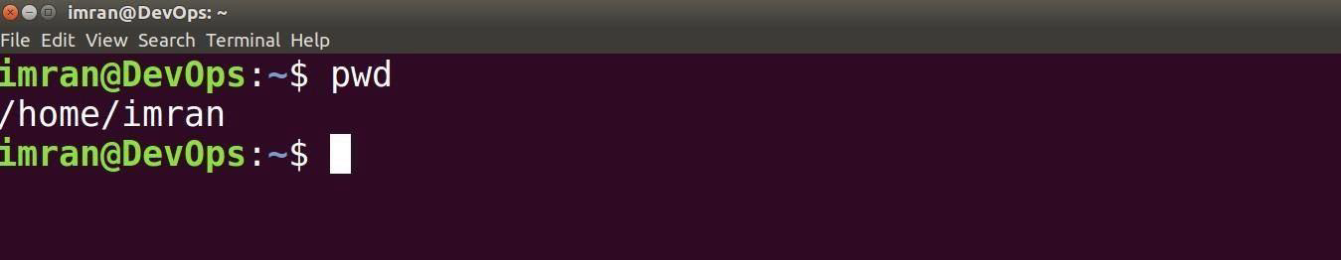

➔ _**Create a directory/folder in your home directory.**



➔ _**Change your current working directory to linux-practices(Go to linux-practices folder).**



➔ _**Create some more directories and list them with “ls” command.**

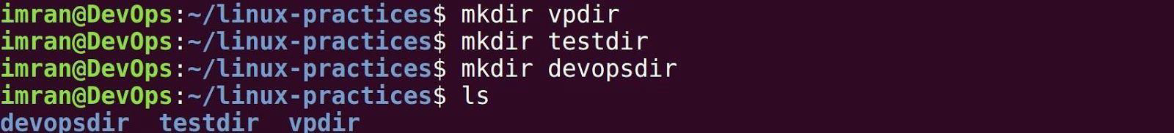

➔ _**Create some empty files with “touch” command and list them.**



➔ _**Reconfirm your location in your system.**

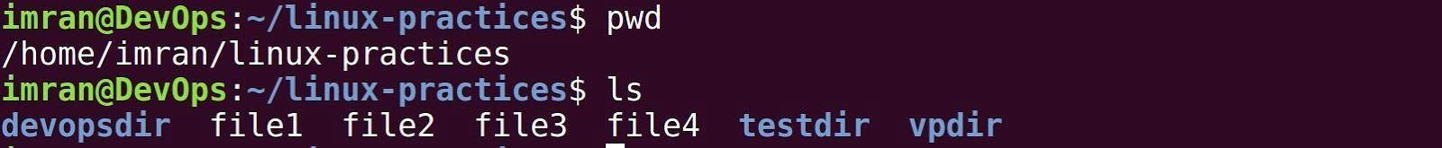

**Absolute path and Relative path**

**What is a path?**

A path is a unique location to a file or a folder in a file system of an OS. A path to a file is a combination of / and alpha-numeric characters.

**What is an absolute path?**

An absolute path is defined as the specifying the location of a file or directory from the root directory(/). In other words we can say absolute path is a complete path from start of actual filesystem from / directory.

**Some examples of absolute path:**

**/home/imran/linux-practices/**

**/var/ftp/pub**

**/etc/samba.smb.conf**

**/boot/grub/grub.conf**

If you see all these paths started from / directory which is a root directory for every Linux/Unix machines.

**What is the relative path?**

Relative path is defined as path related to the present working directory(pwd). Suppose I am located in /home/azhar and I want to change directory to /home/azhar/linux-practices. I can use relative path concept to change directory to linux-practices and also devopsdir directory.

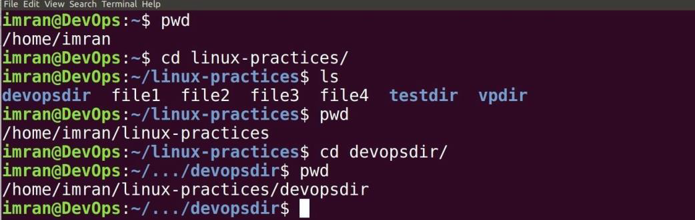

If you see all these paths did not start with / directory.

➔ _**Creating directories in devopsdir directory with absolute and relative path.**

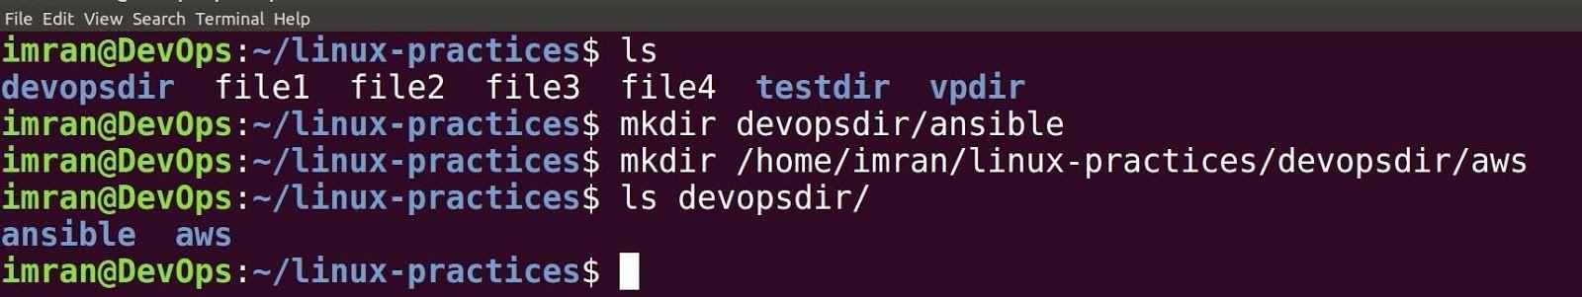

➔ _**Copying files into directory.**

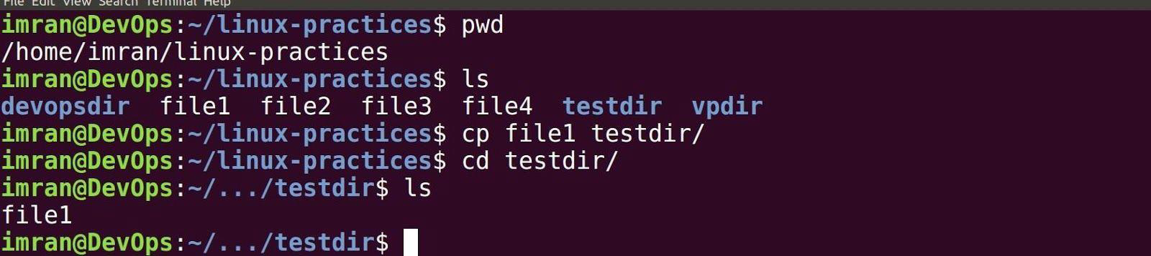

➔ _**Copying directories from one location to another.**

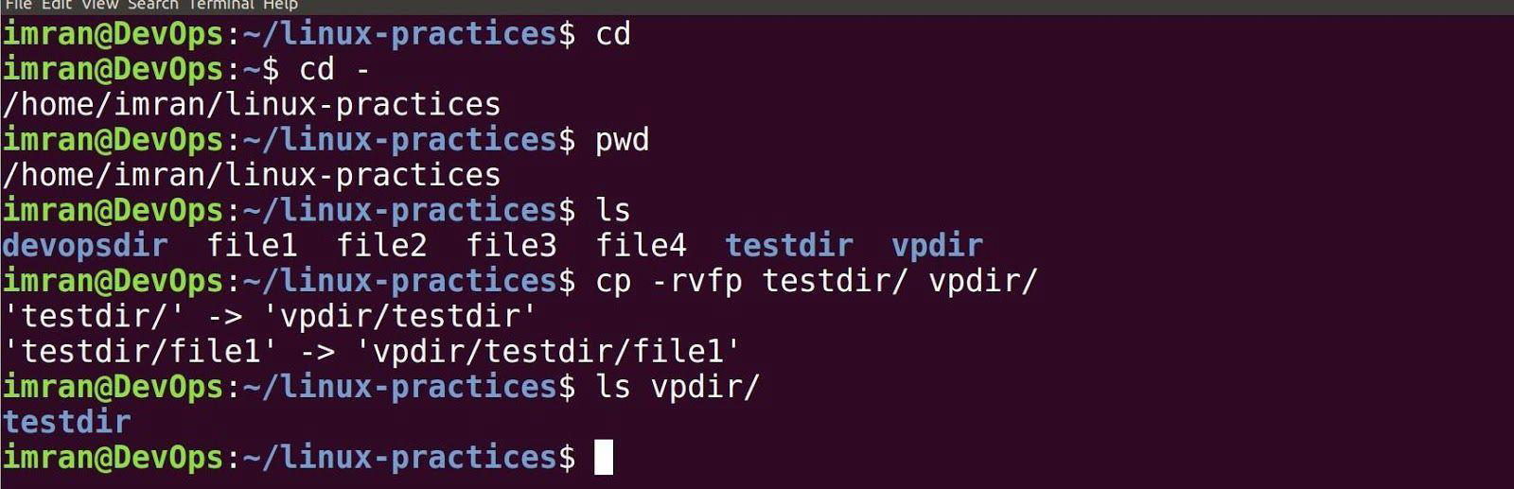

➔ _**Moving files from one location to another.**

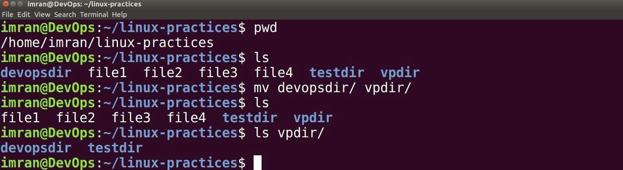



➔ _**Removing files and directories.**

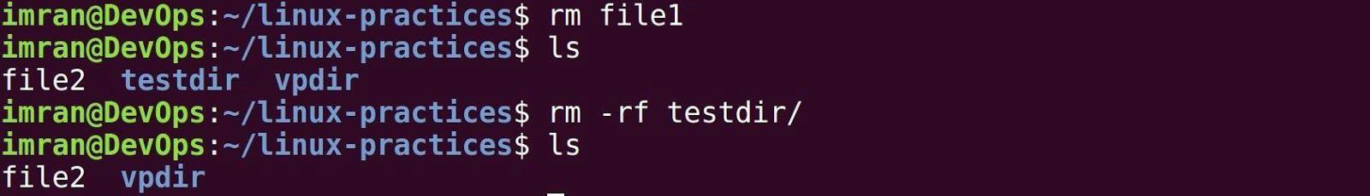

**VIM EDITOR**

➔ Install vim editor.

➔ _**Open up a file in vim editor**

➔ _**Hit i to enter into insert mode**

**=> type few lines => hit Esc**

**=> type :wq**

**=> Enter.**

➔ _**Read file with cat command.**

**Cat file1 > file2**

**Tac file1**

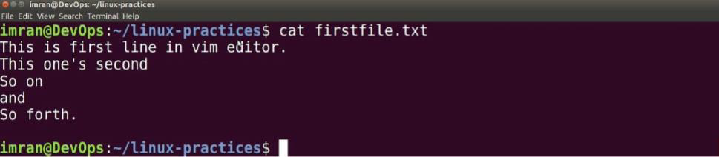

**VIM EDITOR**

VI Visual display editor

VIM Visual display editor improved

This is command mode editor for files. Other editors in Linux are emacs, gedit

vi editor is most popular

It has 3 modes:

1 Command Mode

2 Insert mode (edit mode)

3 extended command mode

Note: When you open the vim editor, it will be in the command mode by default.

|  |  |
| --- | --- |
| Command Mode: gg | To go to the beginning of the page |
| G | To go to end of the page |
| **w** | To move the cursor forward, word by word |
| b | To move the cursor backward, word by word |
| nw | To move the cursor forward to n words **(SW)** |
| nb | To move the cursor backward to n words **{SB)** |
| u | To undo last change (word) |

Extended Mode: ( Colon Mode)

Extended Mode is used for save and quit or save without quit using "Esc" Key with":"

|  |  |
| --- | --- |
| Esc+:w | To Save the changes |
| Esc+:q | To quit (Without saving) |
| Esc+:wq | To save and quit |
| Esc+:w! | To save forcefully |
| Esc+wq! | To save and quit forcefully |
| Esc+:x | To save and quit |
| Esc+:X | To give passw or d to the file and r emove password |
| Esc+:20(n) | To go to line no 20 or n |
| Esc+: se nu | To set the line numbers to the file |
| Esc+:se nonu | To Remove the set line numbers |

**Is command options**

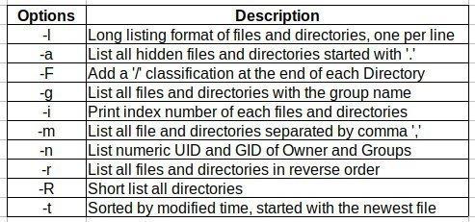

**Types of files in linux.**

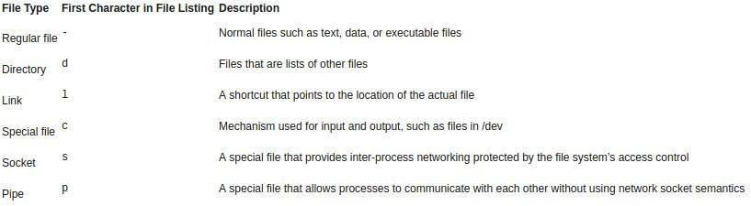

**Symbolic links**

Symbolic links are like desktop shortcuts we use in windows.

Create a soft link for /var/log directory in our current working directory.

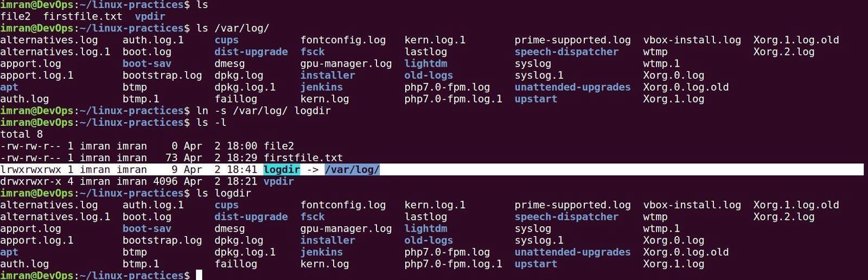

**4. Filter & IO redirection command.**

**Grep**

grep command is used to find texts from any text input. Passwd file: stores information about all the users in the system

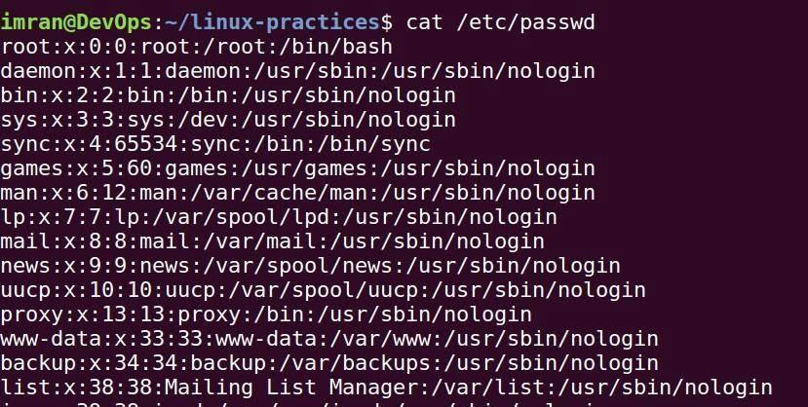

➔ _**Finding line which contains word as “root” from /etc/passwd file.**



➔ _**Linux is case sensetive, Root is diffrent that root. Ignoring case in grep with -i option.**



➔ _**To display things except the given word use -v option**

**Filter Commands**

• _**less: Displays file content page wise or line**

**wise. Ex: less /etc/passwd**

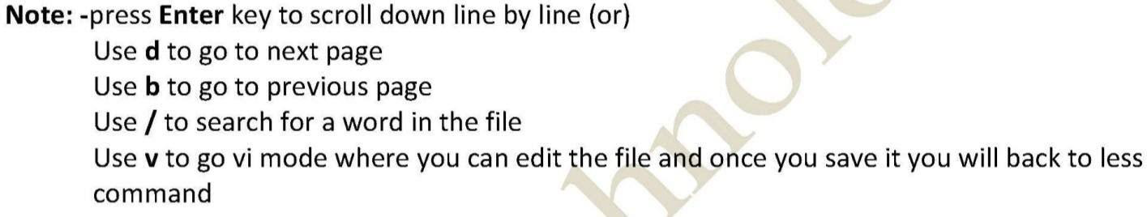

* **more**

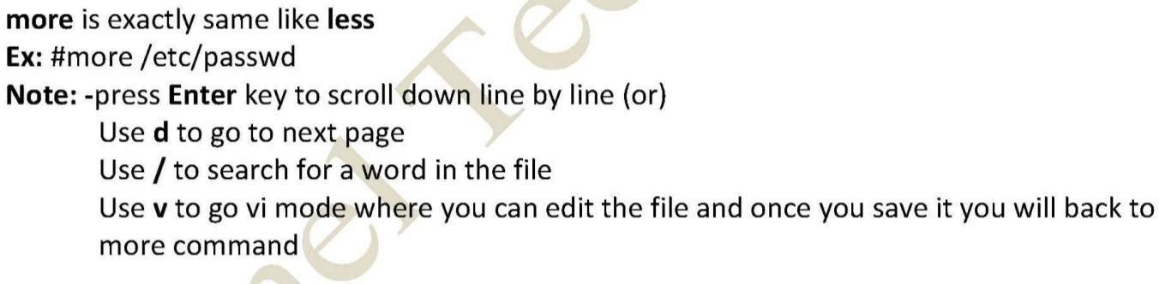

**• head**

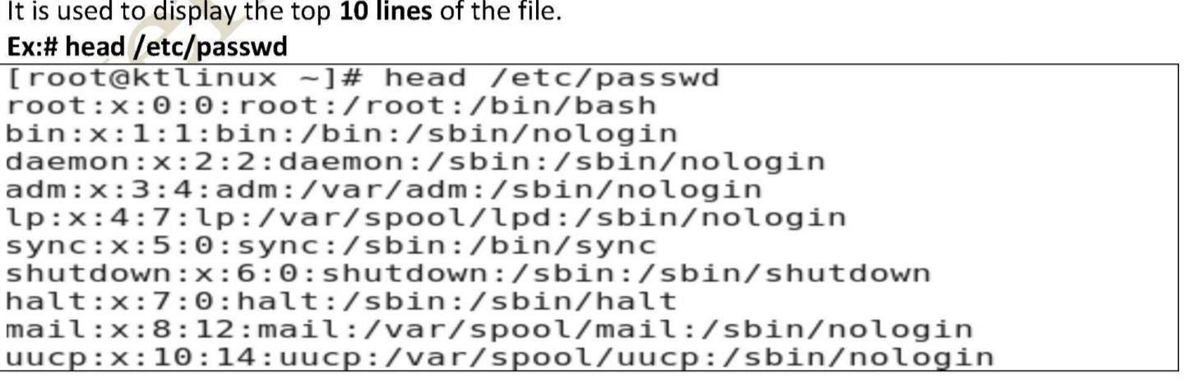

• **tail**

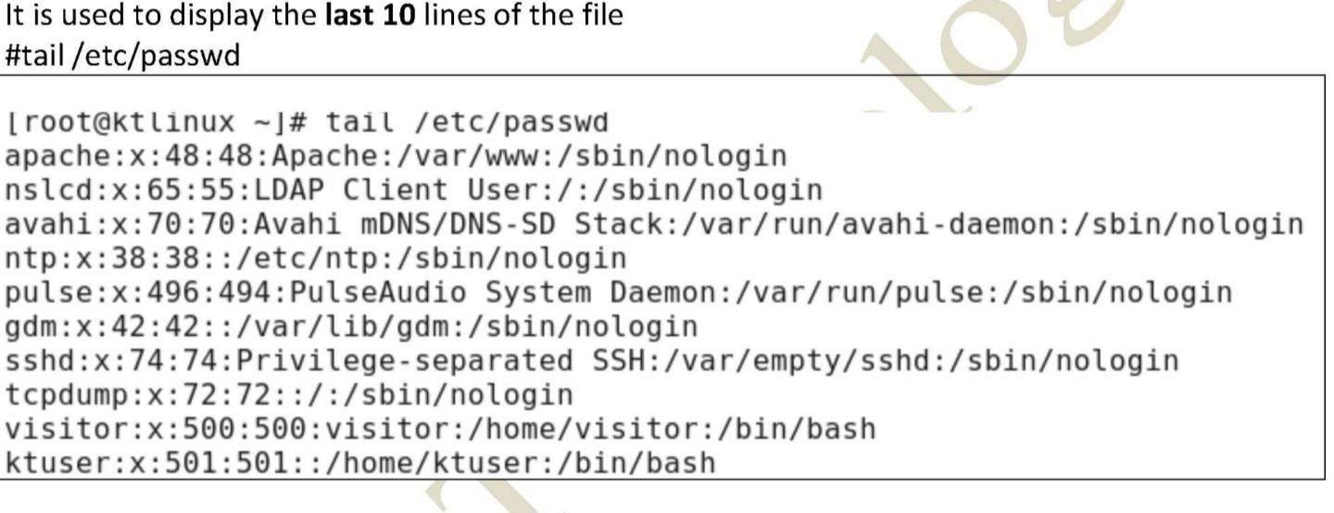

**• cut**

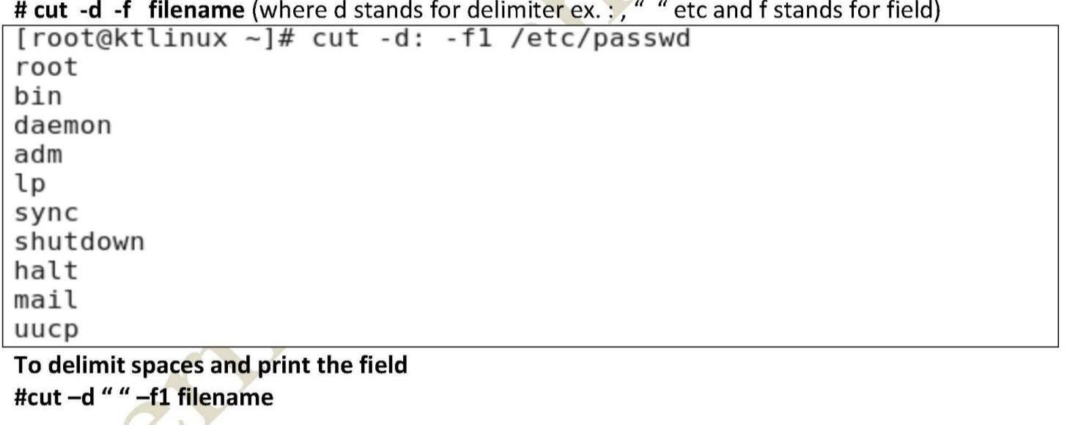

**• sed**

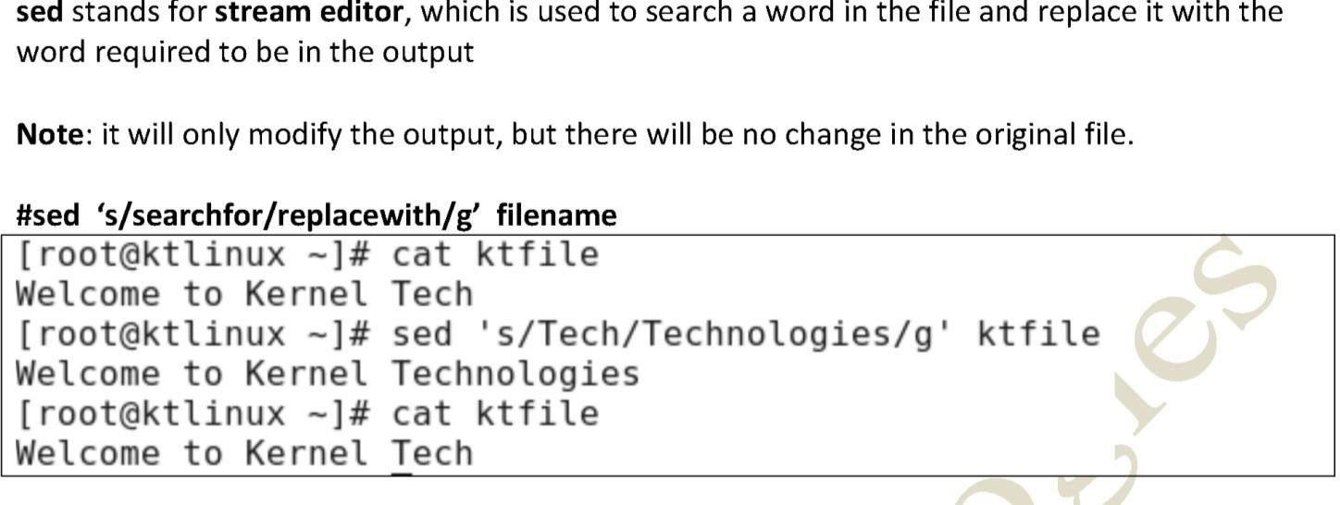

**I/O redirection:**

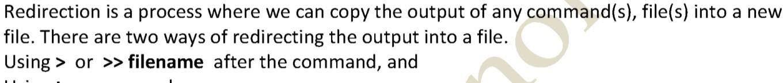

➔ _**Create a file named devopstools with below content.**

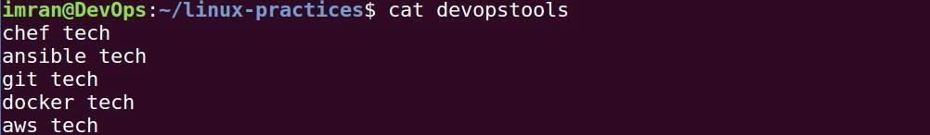

➔ _**Search for text “tech” replace it with “tools” and redirect output to a new file.**

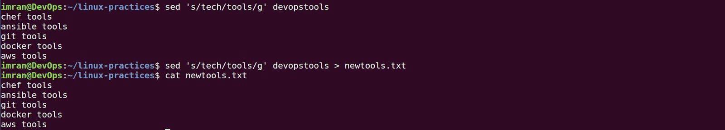



➔ _**Appending another output in same file with “>>” .**

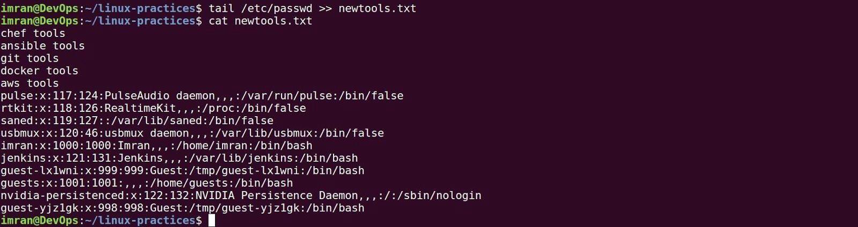

➔ **Redirecting only error to a file “2>>”**

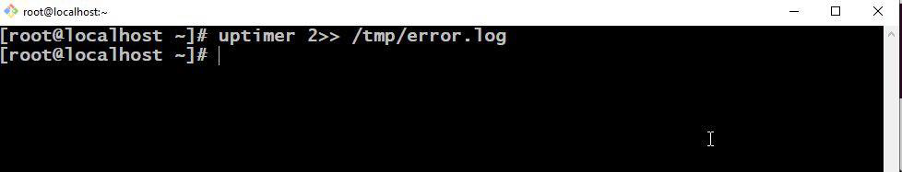

➔ **Redirecting all the out put to a file “&>>”.**

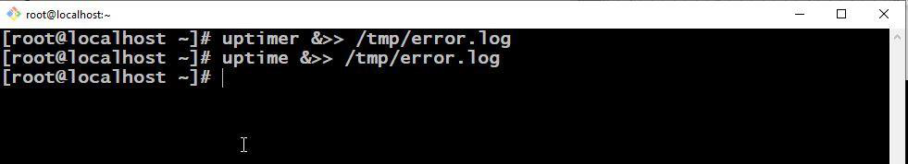

**Piping**

So far we've dealt with sending data to and from files. Now we'll take a look at a mechanism for sending data from one program to another. It's called piping and the operator we use is ( | ). What this operator does is feed the output from the program on the left as input to the program on the right.

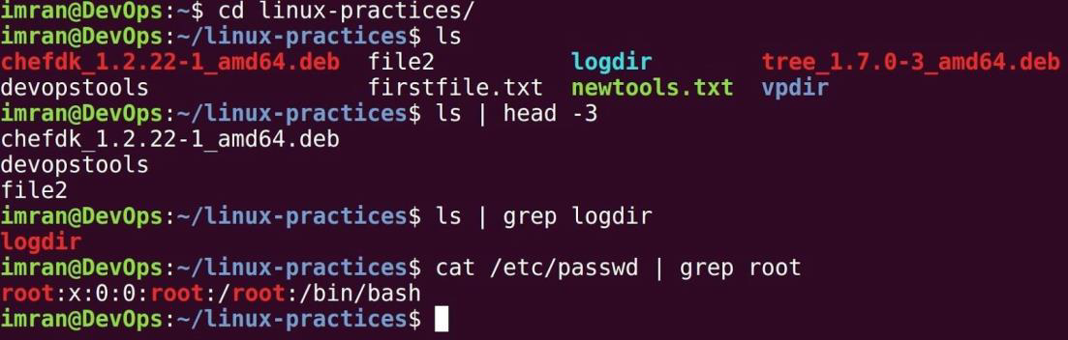

**Find:**





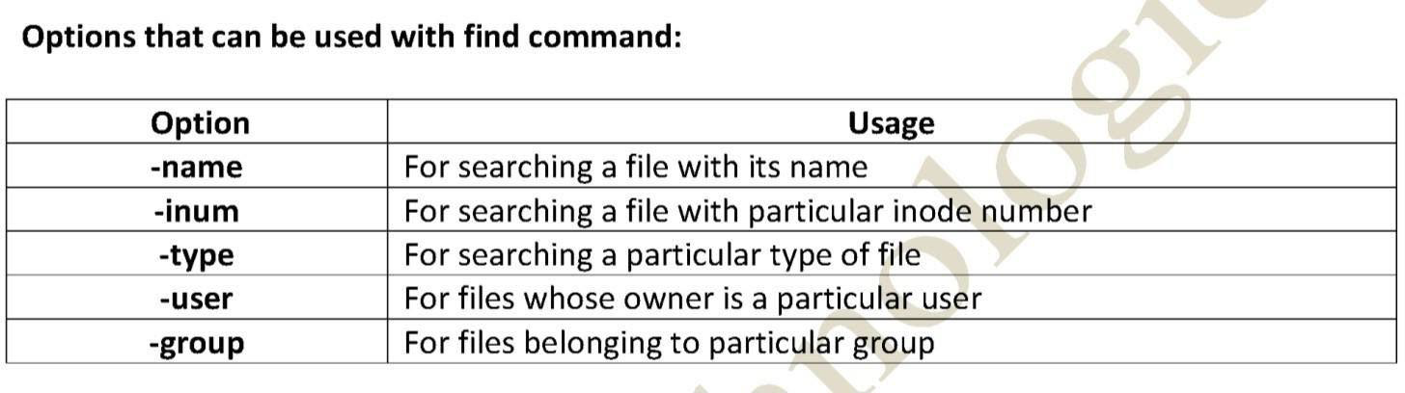

**5. Users & Groups.**

**USERS**

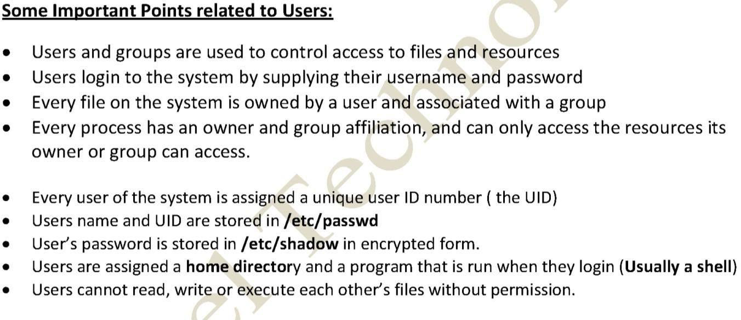

**Types of user**

|  |  |  |  |  |  |
| --- | --- | --- | --- | --- | --- |
| **TYPE** | **EXAMPLE** | **USER ID (ID)** | **GROUP ID (GID)** | **HOME DIR** | **SHELL** |
| **ROOT** | **root** | **0** | **0** | **/root** | **/bin/bash** |
| **REGULAR** | **azhar, vagrant** | **1000 to 60000** | **1000 to 60000** | **/home/username** | **/bin/bash** |
| **SERVICE** | **ftp, ssh, apache** | **1 to 999** | **1 to 999** | **/var/ftp etc** | **/sbin/nologi n** |

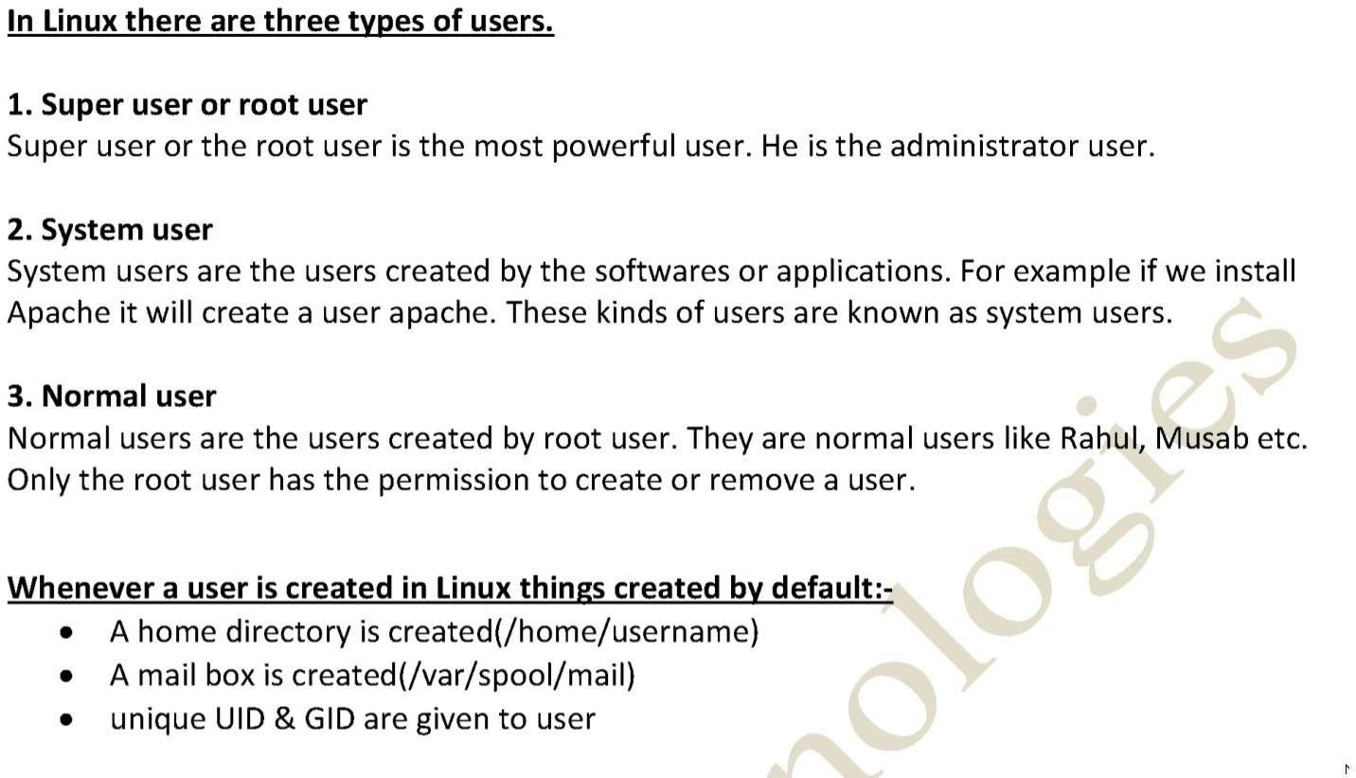

**Passwd file**

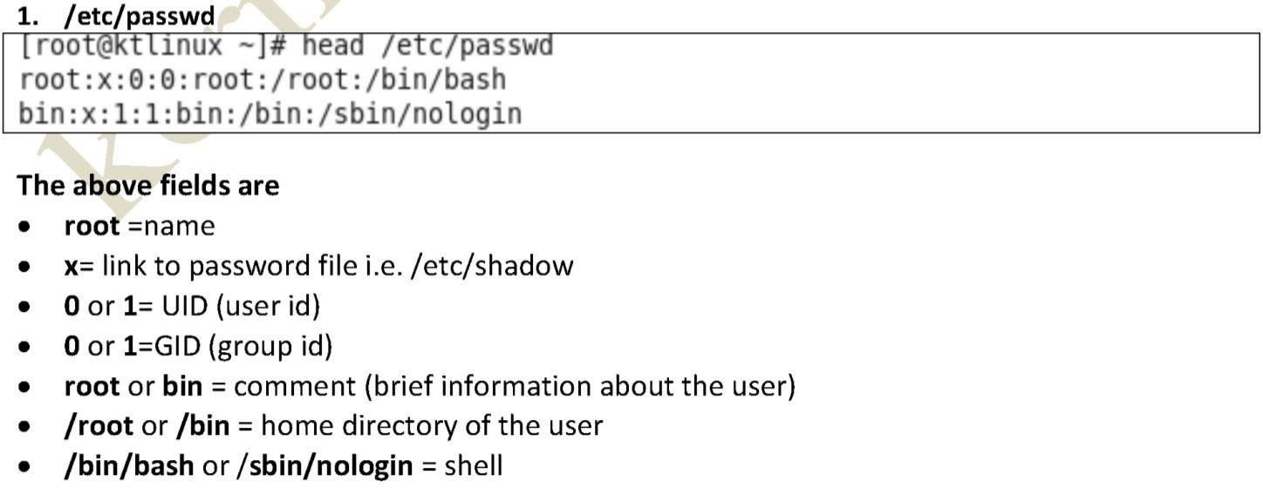

**Group file**

**2. /etc/group**

The file /etc/group stores group information. Each line in this file stores one group entry.

**Group name, group password, GID, group members**

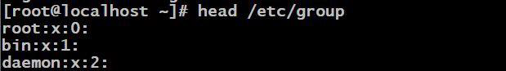

**ADD USER, SET PASSWORD & SWITCH TO USER**

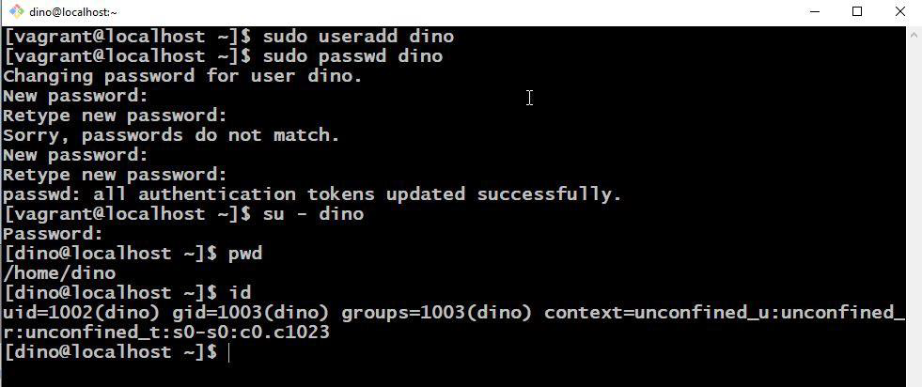

**ADD USER, GROUP & USER INTO GROUP**

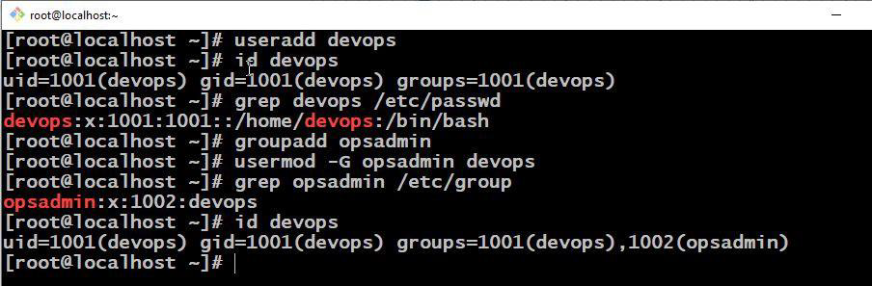

**DELETE USER & GROUP**

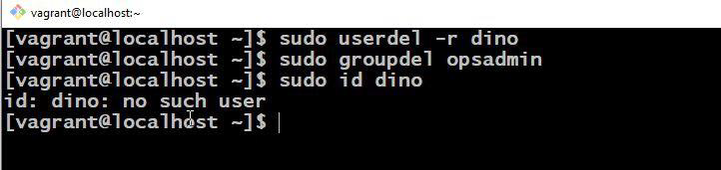

**3. The /etc/shadow file**

This file stores users’ password and password related information. Just like */etc/passwd* file, this file also uses an individual line for each entry.

1. Username

2. Encrypted password

3. Number of days when password was last changed

4. Number of days before password can be changed

5. Number of days after password must be changed

6. Number of days before password expiry date to display the warning message.

7. Number of days to disable the account after the password expiry

8. Number of days since the account is disabled

9. Reserved field

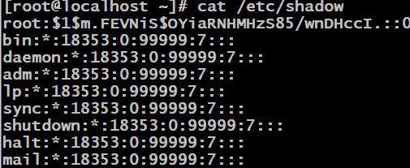

**USER & GROUP cheatsheet**

|  |  |
| --- | --- |
| COMMANDS | DESCRIPTION |
| useradd | Creates user in RedHat |
| adduser | Creates user in ubuntu |
| id | Shows user info |
| groupadd | Creates group |
| usermod -G grpnam usrname | Adds user to group |
| passwd | set/reset password |
| userdel -r | removes user with home dir |
| groupdel | removes group |
| last | shows last login in system |
| who | who is logged into system |
| whoami | username |
| lsof -u user | List files opened by user |

**6. File permissions**

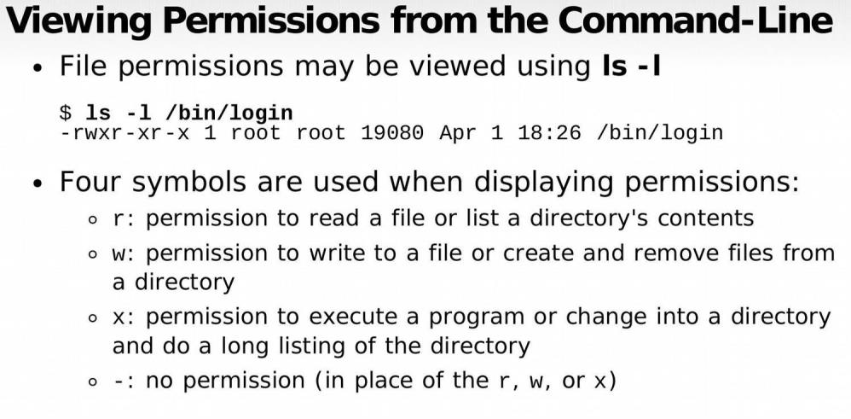

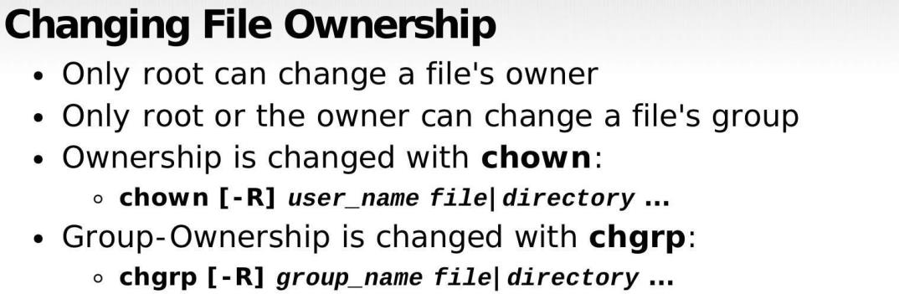

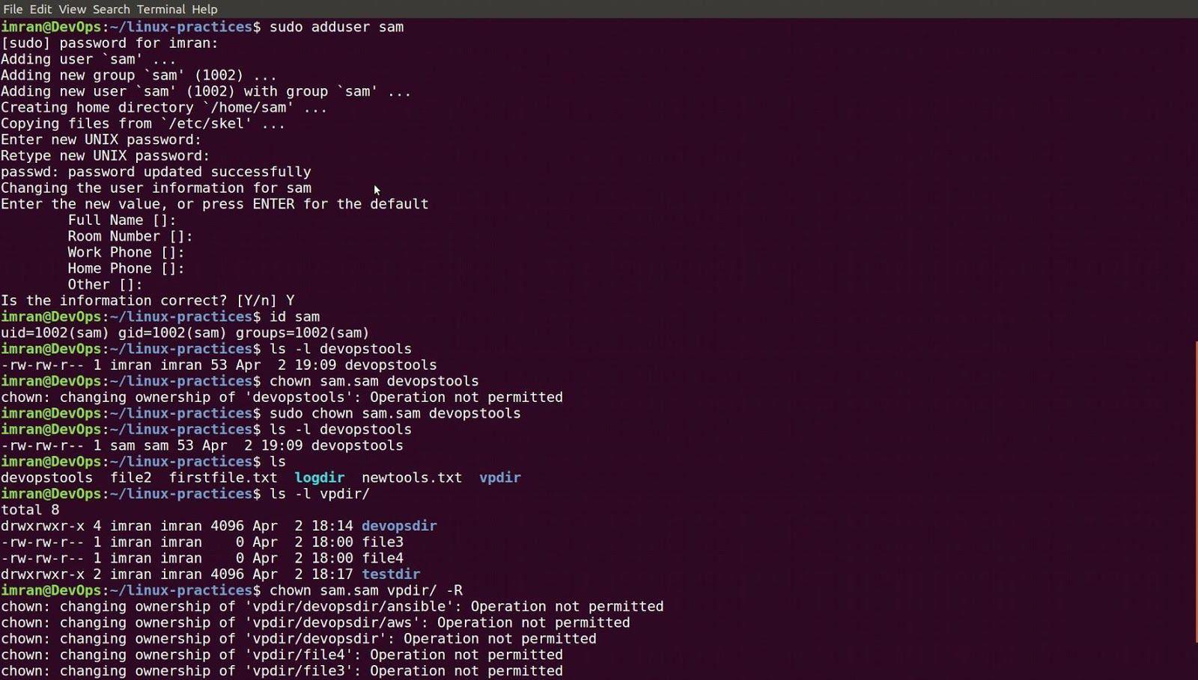

**Changing Permissions - Numeric Method**

Uses a three-digit mode number

* + - first digit specifies owner 's permissions
    - second digit specifies group permissions
    - third digit represents others' permissions

Permissions are calculated by adding:

* + - 4 (for read)
    - 2 (for write)
    - 1 (for execute)

Example:

* + - **chmod 640 myfile**

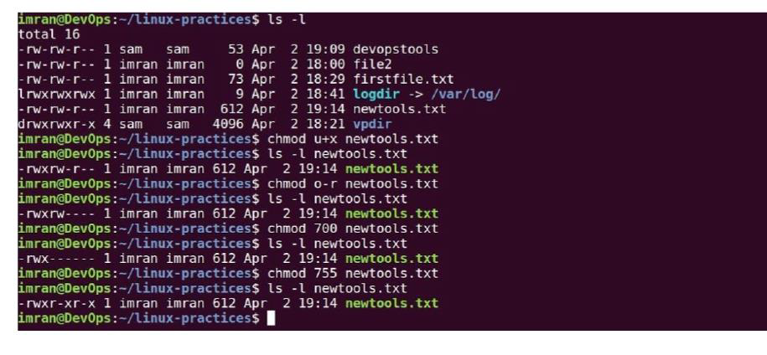

**7. Sudo**

sudo gives power to a normal user to execute commands which is owned by root user. Example shown below:

**If a user has already full sudoers privilege, it can become a root user anytime.**

➔ **sudo -i changes from normal user to root user**

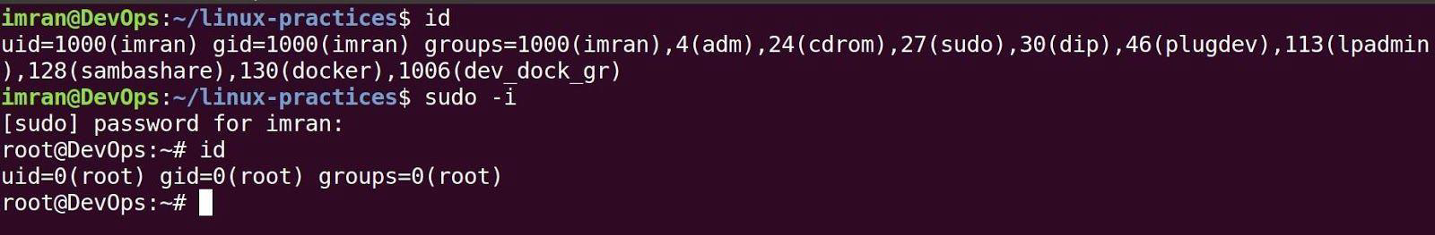

**Note: User imran was already a sudo user with full privilege.**

➔ **Adding user sam in sudoers list.**



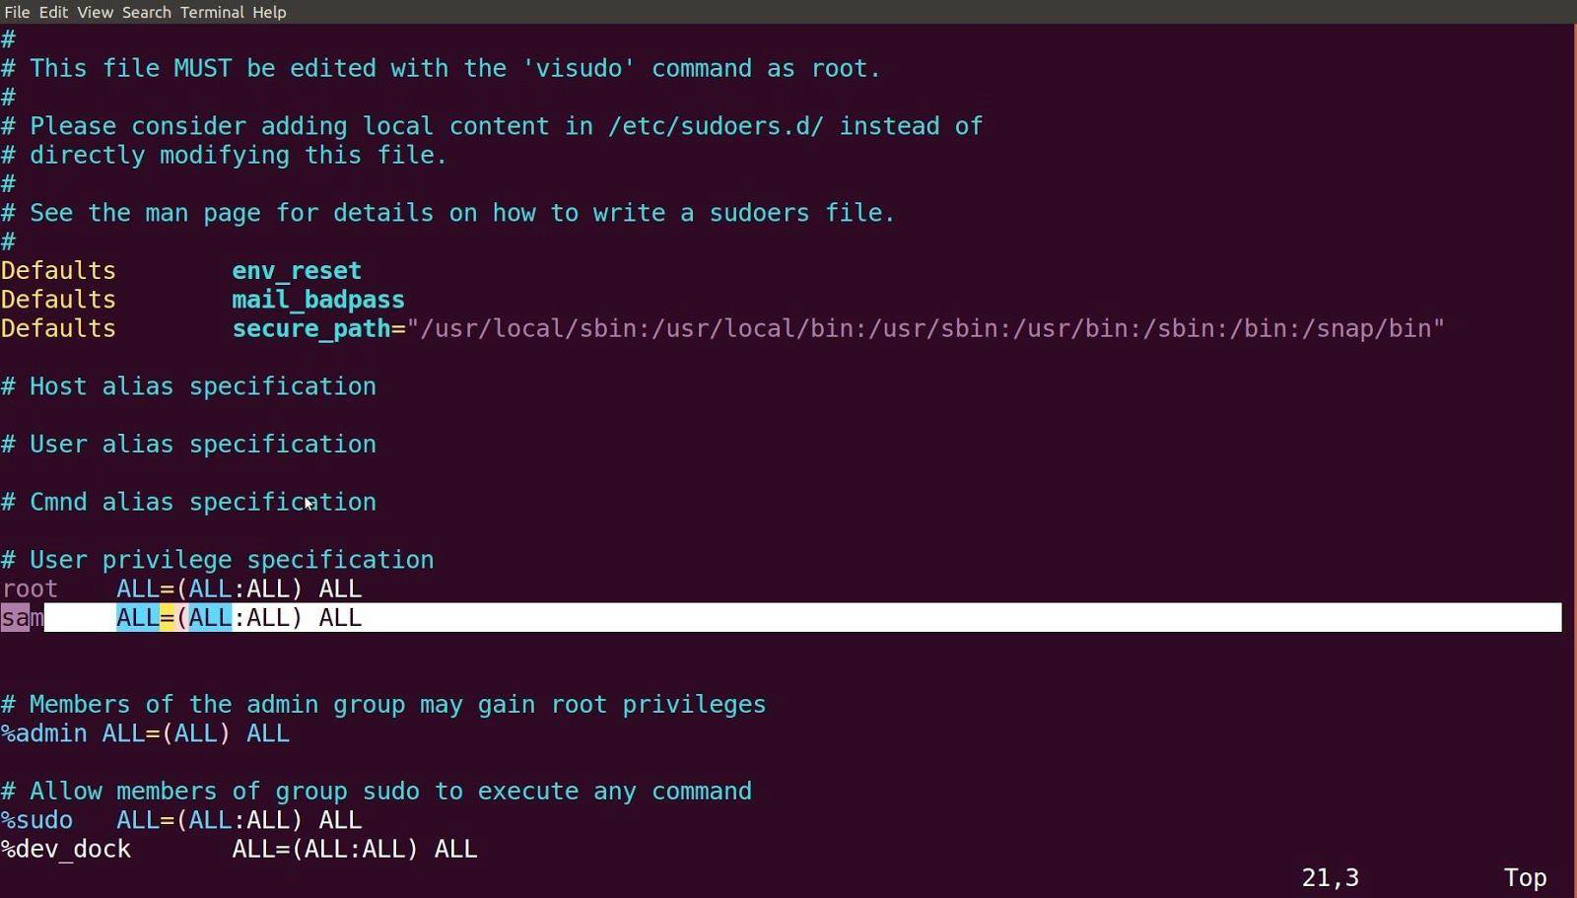

➔ **Like a user a group can also be added into sudoers list.**



➔ **Every time you enter sudo command it asks your own password. To turn that off use NOPASSWD in sudoers file.**



➔ **Changing to any other user with “su -” command.**



➔ **Become a root user from sam user login.**



**8. Software Management.**

➔ **Download package from internet.**

**For CentOS**

**To install Tree**

# curl https://rpmfind.net/linux/centos/7.9.2009/os/x86_64/Packages/tree-1.6.0-10.el7.x86_64.rpm -o tree-1.6.0-10.el7.x86_64.rpm

# rpm -ivh tree-1.6.0-10.el7.x86_64.rpm

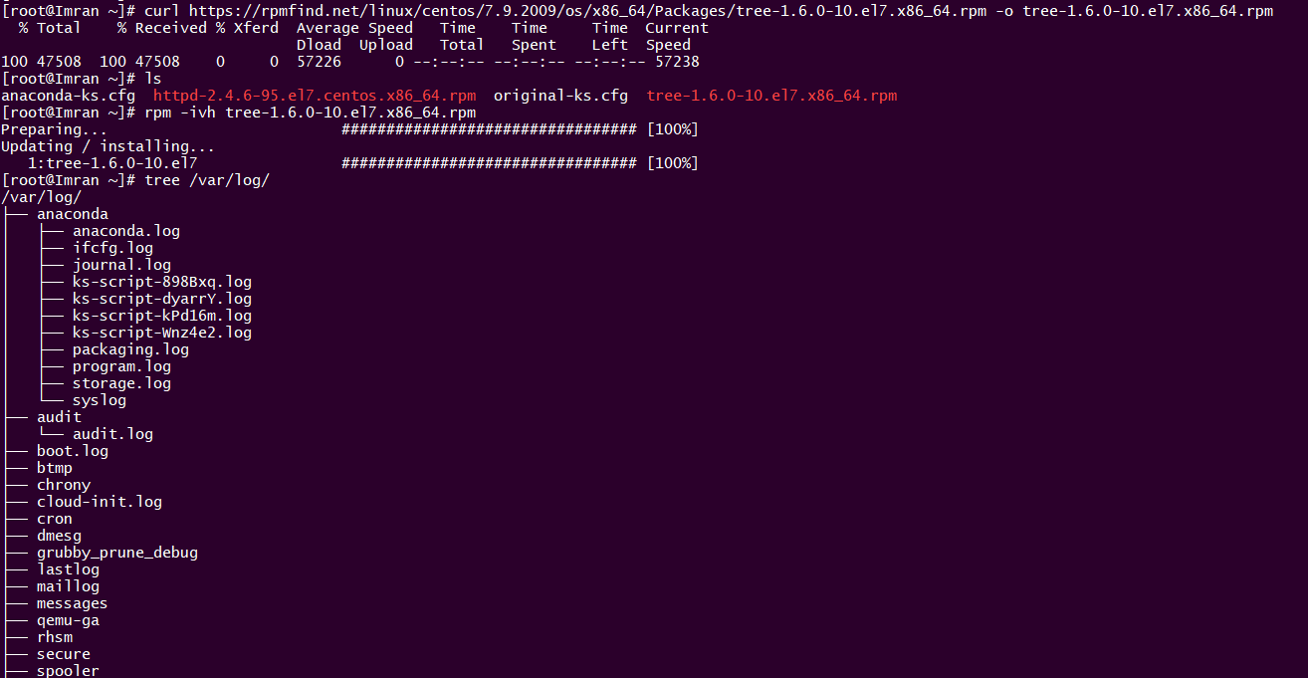

**To install httpd**

# curl [https://rpmfind.net/linux/centos/7.9.2009/os/x86_64/Packages/httpd-2.4.6-95.el7.centos.x86_64.rpm -o httpd-2.4.6-95.el7.centos.x86_64.rpm](https://rpmfind.net/linux/centos/7.9.2009/os/x86_64/Packages/httpd-2.4.6-95.el7.centos.x86_64.rpm%20-o%20httpd-2.4.6-95.el7.centos.x86_64.rpm)

# rpm -ivh httpd-2.4.6-95.el7.centos.x86_64.rpm

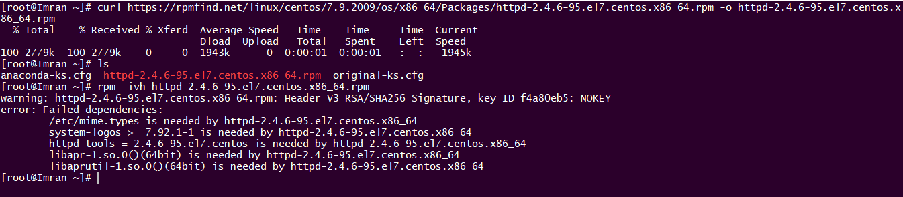

Due to Dependencies its failing and it will be installed one we install all the dependencies. But what if we have Hundreds of dependencies, And that can be solved easily by other package managers like YUM .

**repos. d/** directory. It reads each YUM Repository **configuration file to get the information required to download and install new software**, resolves software dependencies and installs the required RPM package files. YUM Repository configuration files must: be located in /etc/yum.repos.d

# ls /etc/yum.repos.d/



**Shows the usage of YUM Command with options**

# yum –help

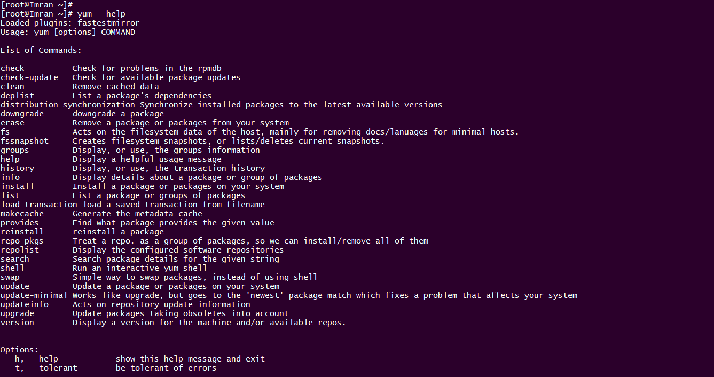

**To Update all your packages**

**# yum update**

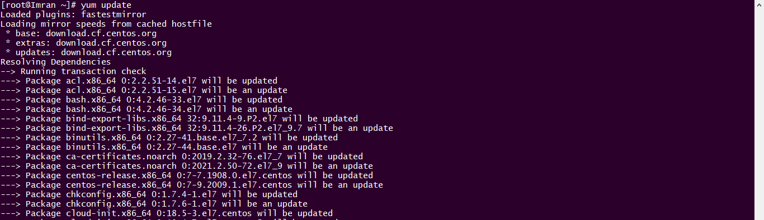

**To install httpd**

# yum install httpd -y

**To remove httpd**

**# yum remove httpd -y**

**--Continue in linux quickstart pdf file.**

Exercises:

### Exercise 1: Basic Command Line Operations

**Question 1:** How do you display the current directory you're in?

**Answer:** The **pwd** command stands for "print working directory". Typing **pwd** and pressing Enter will display the current directory.

**Question 2:** Explain the function of the ls command.

**Answer:** The **ls** command is used to list files and directories in the current directory. It shows the names of files and directories present within the specified location.

**Question 3:** How do you create a new directory named "myFolder"?

**Answer:** To create a new directory named "myFolder", use the command **mkdir myFolder**.

### Exercise 2: File Manipulation

**Question 1:** How can you create an empty text file named "example.txt"?

**Answer:** You can create an empty text file named "example.txt" using the **touch** command like this: **touch example.txt**.

**Question 2:** Explain how to copy a file from one location to another.

**Answer:** To copy a file from one location to another, use the **cp** command followed by the source file and destination file/directory. For example: **cp sourceFile.txt destinationDirectory/**.

**Question 3:** How do you delete a file named "oldFile.txt"?

**Answer:** To delete a file named "oldFile.txt", use the **rm** command: **rm oldFile.txt**.

### Exercise 3: User and Permissions

**Question 1:** How do you display information about the users currently logged into the system?

**Answer:** To display information about users currently logged in, use the **who** or **w** command.

**Question 2:** Explain how to change the permissions of a file named "myFile.txt" so that only the owner can read and write to it.

**Answer:** You can change the permissions using the **chmod** command. For example: **chmod 600 myFile.txt**.

**Question 3:** What command can you use to add a new user to the system?

**Answer:** The **useradd** command is used to add a new user to the system. For example: **useradd newUser**.

### Exercise 4: System Information

**Question 1:** How do you display the amount of free and used memory in the system?

**Answer:** To display memory usage information, use the **free** command.

**Question 2:** Explain how to view information about the CPU(s) installed in the system.

**Answer:** The **lscpu** command is used to display information about the CPU(s) installed in the system.

**Question 3:** What command can you use to check the current running processes?

**Answer:** The **ps** command, when used without any options, displays the current running processes.

These exercises cover some fundamental aspects of using the Linux command line, file manipulation, user management, and system information retrieval. They aim to test and reinforce understanding of basic Linux commands and concepts.

### Real-Time Project: Creating a Simple Website Using Amazon Linux EC2

**Project Overview:** This project will guide you through creating a basic static website using HTML/CSS and hosting it on an Amazon EC2 instance running Amazon Linux.

**Steps Involved:**

1. **Launch Amazon EC2 Instance:**
   * Log in to your AWS Management Console and launch an EC2 instance with Amazon Linux.
   * Connect to your EC2 instance using SSH.
2. **Update Packages:**
   * Update the package manager:

**sudo chmod 644 /var/www/html/index.html**

1. **Install Apache Web Server:**
   * Install Apache on Amazon Linux:

**sudo yum install httpd -ysudo** yum install httpd -y

1. **Start Apache Service:**
   * Start the Apache service:

**sudo systemctl start httpd**art httpd

* + Enable Apache to start on boot:

**sudo systemctl enable httpd**

1. **Create Website Files:**
   * Navigate to the Apache document root directory:

**cd /var/www/html/www**/html

* + Create an **index.html** file and add basic HTML content:

**sudo nano index.htmlsudo** nano index.html

<html>  
 <head>  
 <title>Welcome to DevOps and AWS CLOUD learning</title>  
 </head>  
 <body>  
 <h1>Welcome to our website</h1>  
 <p>This is a simple website hosted on AWS.</p>  
 </body>  
</html>

1. **Set Permissions:**
   * Set correct permissions for the website files:

**sudo chmod 644 /var/www/html/index.html**

1. **Access the Website:**
   * Open a web browser and enter your EC2 instance's public IP address or public DNS into the address bar. For example: **http://ec2-xx-xx-xx-xx.compute-1.amazonaws.com**.
   * You should see your simple website's content displayed in the browser.

**Project Outcome:** Following these steps, you'll have created a basic static website using HTML/CSS and hosted it on an Amazon EC2 instance running Amazon Linux with Apache. This project provides a clear understanding of setting up a web server, creating website files, configuring Apache, and accessing the website through a browser on an Amazon Linux EC2 instance.

# AWS EC2

# Bash Scripting

Shell scripting involves writing scripts (programs) using the shell of an operating system, such as Bash (Bourne Again SHell) on Unix/Linux systems or Command Prompt on Windows. It allows automating tasks, executing commands, and manipulating files and data.

To start with Shell scripting, let's cover some basic concepts and then move on to exercises:

### Concepts:

1. **Shebang:** A line at the beginning of the script that specifies the shell to be used. It looks like **#!/bin/bash** for Bash scripts.
2. **Variables:** Used to store data. They can be created by assigning values (**variable_name=value**) and accessed using **$** followed by the variable name (**$variable_name**).
3. **Comments:** Lines beginning with **#**. They are used for explaining code and are ignored by the shell.
4. **Input/Output:** Use **echo** to print output to the terminal, and **read** to take input from the user.
5. **Conditional Statements:** **if**, **else**, and **elif** (else if) statements to execute code based on conditions.
6. **Loops:** **for**, **while**, and **until** loops to execute code repeatedly.
7. **Functions:** Blocks of code that can be reused by calling their names.

**Exercises:**

Exercise 1: Hello World

Create a script that prints "Hello, World!" to the terminal.

First-script.sh

#!/bin/bash

echo "Hello, World!"

**Exercise 2:** **Variables and Input**

Write a script that takes a user's name as input and displays a greeting.

#!/bin/bash

echo "Enter your name:"

read name

echo "Hello, $name! Welcome to Shell scripting."

#### **Exercise 3: Conditional Statements**

Create a script that checks if a number is even or odd.

#!/bin/bash

echo "Enter a number:"

read num

if ((num % 2 == 0)); then

echo "$num is even."

else

echo "$num is odd."

fi

#### **Exercise 4: Loops**

Write a script to display numbers from 1 to 5 using a **for** loop.

#!/bin/bash

for i in {1..5}; do

echo $i

done

#### **Exercise 5: Functions**

Create a script that defines a function to greet someone.

#!/bin/bash

greet() {

echo "Hello, $1!"

}

name="Alice"

greet $name

As you progress, you can explore more advanced topics like file manipulation, command-line arguments, error handling, etc. Shell scripting is versatile and can be used for various tasks!

Top of Form

Bottom of Form

**PROJECT:**

Let's create a simple project using shell scripting step by step. In this example project, we'll create a basic file organizer script that organizes files by their types into respective directories.

Project: File Organizer

Step 1: **Creating the Shell Script**

Open a text editor or terminal and create a new file named file_organizer.sh.

Step 2: **Shebang and Variables**

Add the shebang line and define variables for source directory and destination directories for different file types.

#!/bin/bash

# Source directory containing files to organize

source_dir="/path/to/source_directory"

# Destination directories for different file types

destination_dir="/path/to/destination_directory"

#### **Step 3: Creating Destination Directories**

Create directories for different file types inside the destination directory.

# Inside file_organizer.sh

# Create destination directories if they don't exist

mkdir -p "$destination_dir"/{Images,Videos,Documents,Others}

#### **Step 4: Organizing Files**

Use **find** command to identify files and move them to respective directories based on their types.

# Inside file_organizer.sh

# Organize files by type

find "$source_dir" -type f -exec bash -c '

file="$1"

case "$file" in

*.jpg|*.png|*.gif) mv "$file" "$destination_dir/Images" ;;

*.mp4|*.mov|*.avi) mv "$file" "$destination_dir/Videos" ;;

*.pdf|*.doc|*.txt) mv "$file" "$destination_dir/Documents" ;;

*) mv "$file" "$destination_dir/Others" ;;

esac

' bash {} \;

#### **Step 5: Execution and Testing**

Save the file and make it executable:

chmod +x file_organizer.sh

Replace **/path/to/source_directory and /path/to/destination_directory** with the actual paths.

Execute the script:

**./file_organizer.sh**

This script will move image files to the Images directory, video files to the Videos directory, document files to the Documents directory, and any other files to the Others directory.

Please ensure to test this script on a test directory with sample files to avoid unintentional movement or loss of important data.

This is a simple project illustrating how you can use shell scripting to automate file organization. You can expand this project by adding error handling, user prompts, or even additional file types and directories based on your requirements.

# GIT

Introduction:

Distributed Version Control System. Or Source Code Management.

Working directory🡪staging area🡪local repository🡪git push.

**It is used for:**

* Tracking code changes
* Tracking who made changes
* Coding collaboration

**What does Git do?**

* Manage projects with **Repositories**
* **Clone** a project to work on a local copy
* Control and track changes with **Staging** and **Committing**
* **Branch** and **Merge** to allow for work on different parts and versions of a project
* **Pull** the latest version of the project to a local copy
* **Push** local updates to the main project.

**Working with Git**

* Initialize Git on a folder, making it a **Repository**
* Git now creates a hidden folder to keep track of changes in that folder
* When a file is changed, added or deleted, it is considered **modified**
* You select the modified files you want to **Stage**
* The **Staged** files are **Committed**, which prompts Git to store a **permanent** snapshot of the files.
* Git allows you to see the full history of every commit.
* You can revert back to any previous commit.
* Git does not store a separate copy of every file in every commit, but keeps track of changes made in each commit!

**Commit id**: Store changes in repository, you’ll get one commit-ID.

**Git push:** push operations copies changes from a local repository server to a Remote or central Arepo.

**Git pull:** Pull operation copies the changes from a Remote repository to a local machine.

**Git Branch:** Do one repository, but different task.

Teaching style:

**Git add**

**Git commit**

**Git branch**

**Git push**

Project:

Two ec2 instances:

#sudo su

#yum update -y

#yum install git -y

#which git(location of the git install🡪/bin/git)

#git –version

#git config –global user.name “Azhar/Mohammed”

#git config –global user.email “azharinfotech001@gmail.com”

#git config –list

**One-ec2-instance:**

#git init

#touch myfile

#git status

#git add .

#git commit -m “your-message”

#git status

#git log --online

#git show commitid

#git remote add origin <cetralgit url>

#git push -u origin master

**Git branch:**

#git branch

#git branch <branch name>(new branch name)

#git checkout <name of the branch you want to go>

**Git stash:**

To stash an item only applies to modifies

#git stash🡪it went to the stash.

#git stash list

#git stash apply stash@{0}--{1}{2}{3}{4}{5}{6}{7}

#git stash clear

**Git reset:** after adding it and I need to delete after that., revert it to add area.

#git reset <file-name> or

#git reset .

#git reset –hard –deleting all., revert back.

Git revert:

#cat >newfile

#git add .

#git commit -m “code”

#git log –online

#git revert <commit-id>

Reset🡪before commit.

Revert🡪after commit.

**Git tag:**

#git tag -a important -m “this is very imp commit” commit-d

#git tag

#git show important

Installation:

Github account setup.

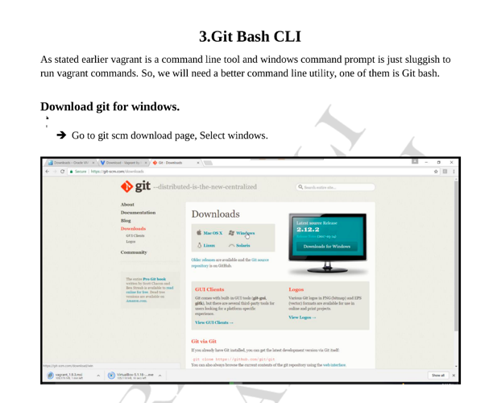

Installation:

#yum install git

#git clone

#git add .

#git commit -m “”

#git push origin master

#git status

#git push origin <branchname>

# MAVEN

# CONTINOUS INTEGRATION

# JENKINS, SONAR, JFROG ARTIFACTORY. CONTINOUS DEPLOYMENT: ANSIBLE DOCKER

# KUBERNETES: